**Introduction**

The administration of oxytocin in order to prevent post-partum hemorrhaging (PPH) in the third stage of labor is recommended, but there is little research on the best method of administration (IV infusion versus IM injection). To address concerns about covariates (variables that may impact the measurement of interest), this analysis was performed. The analysis focused on if the presence of pre-existing conditions or birth order (if this was the mother’s first, second, or third or greater baby) affected total blood loss during active bleeding.

**Dataset and Methods**

This dataset is from a randomized, controlled trial aimed to investigate the effect of IV infusion versus IM injection on 477 mothers in active labor at an Argentinian hospital who did not have c-sections. This study measured 42 different variables; only three were used in this report: The total amount of blood lost during active bleeding (TotalBloodLoss), the presence of a prior illness upon arriving at the hospital (NoPriorIllness), and baby’s birth order (BBO). Both variables NoPriorIllness and BBO are categorical variables; TotalBloodLoss is a numerical variable measured in milliliters. To analyze the data, ANOVA tests were performed to obtain information regarding the differences between groups. Additionally, a bonferroni adjustment was made to the BBO analysis.

**Exploratory Data Analysis**

This data exploration will focus on the bloodloss of two covariates; first the covariate of prior illness will be examined, then the baby's birth order. Given that this dataset meets criteria for the central limit theorem to be met (the sample is sufficiently large, observations are independent of each other and randomly sampled), an ANOVA analysis was able to be performed on both variables.

Looking first at the relationship between total blood loss and the presence of prior illness, table one shows the mean blood loss of those without prior illness is 418.97mL versus the 381.83mL of those who did. The standard deviation for those without prior illness is 411.76mL and for those with is 326.29mL. The sample sizes also differ with 39 individuals coming into the hospital without prior illness and 438 individuals having an illness, meaning these groups are unbalanced. These groups do, however, have equal variance as double the smaller standard deviation (652.58mL) is sufficiently larger than the larger mean (418.97mL) within the unbalanced sample. These findings are visualized in figure 1, where it is clear that, while the IQR is smaller, the mean of no prior illness is greater.

The relationship between total blood loss and birth order can be found in table 3 and figure 2. Looking to table 3, it is seen that for the first, second, and third or more groups the number of individuals is 191, 127, and 159 respectively. They do have equal variance as double the smallest standard deviation (541.72mL) is sufficiently larger than the largest (389.72mL) within this unbalanced sample. The means of the first, second, and third or more groups are 484.76, 338.74, and 301.70 respectively; these confirm the trends seen in figure 2.

**Results**

For the covariate of presence of prior illness, the question being asked was if it had an effect on total blood loss during the third stage of labor. The null hypothesis for this ANOVA test was that the mean total blood loss in mL of those with prior illness is the same as those without $(H_{0}: μ_{Prior Illness}=μ_{No Prior Illness})$. The alternative hypothesis is that there is a difference between the average blood loss in mothers with prior illness and those without $(H_{α}: μ_{Prior Illness}≠μ_{NoPriorIllness})$. The results of this ANOVA test are in table 2, with the p-value being 0.506. Using an alpha value of 0.05, this means that we fail to reject the null hypothesis and conclude that the mean total blood loss in mL of those with prior illness is the same as those without.

For the covariate of baby birth order, the question being asked was if it had an effect on total blood loss during the third stage of labor. The null hypothesis for this ANOVA test was that the mean total blood loss in mL was equal for all birth orders $(H_{0}: μ_{First}=μ_{Second}=μ_{Third or more})$. The alternative hypothesis is that the mean total blood loss in mL is different for at least one of the groups $(H_{α}: at least one group is different)$. The results of this ANOVA test are in table four, which shows the p-value being 2.72e-07. An alpha value of 0.05 causes us to reject the null hypothesis and conclude that at least one of the groups has a differing mean blood loss. To determine which group, a multiple comparison analysis using bonferroni adjustment was used; the results are listed in table 5. Using an alpha value of 0.05, it can be found that the total blood loss in mothers from first-born babies have a different mean than second born (p-value=0.00028) and third or more (p-value=6.4e-07) babies.

**Conclusion**

The aim of this analysis was to address concerns about covariates for total blood loss during the third stage of labor within the study’s dataset. Two covariates were addressed: if the mother entered the hospital with a prior illness and the baby’s birth order. It was found that there was no significant difference in total blood loss between those who had a pre-existing condition and those who did not. For the birth order, it was found that blood loss differs depending on the baby’s birth order. The blood loss for first-born children differs from the blood loss of second, third, or greater children.

Appendix

**Figure 1**

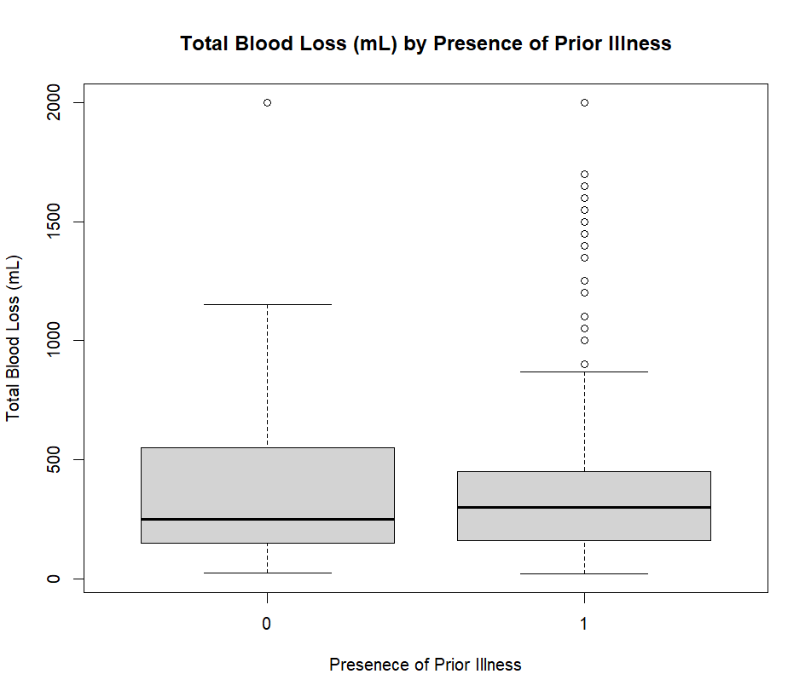

**Figure 2**

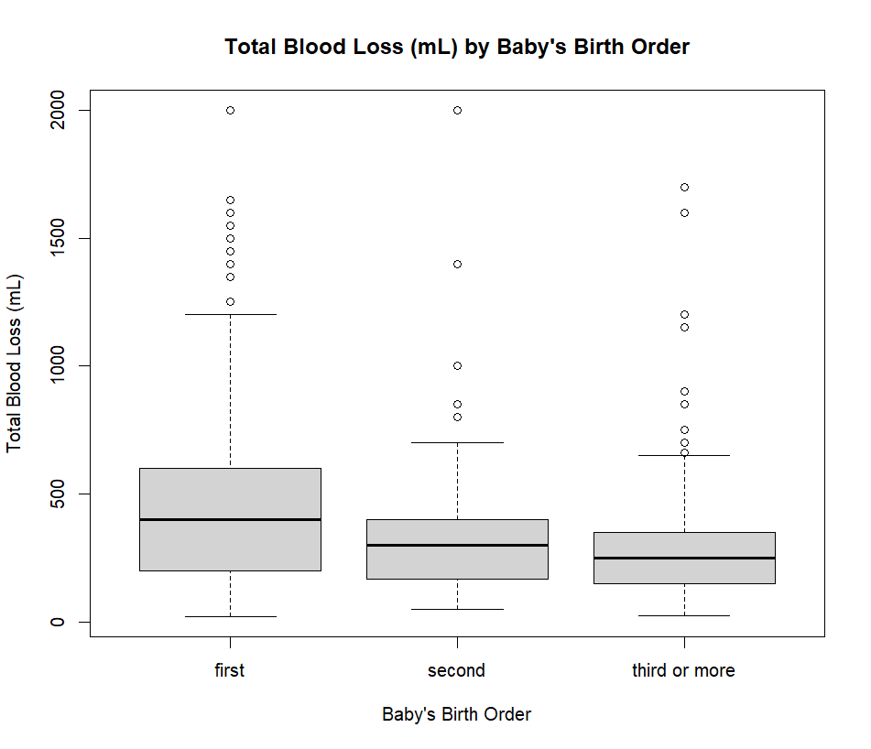

**Table 1**

Summary Statistics for Prior Illness via Blood Loss

|  | n | mean | sd |
| --- | --- | --- | --- |
| No Prior Illness | 39 | 418.97 | 411.76 |
| Prior Illness | 438 | 381.83 | 326.29 |

**Table 2**

Summary of ANOVA Analysis for affect of Prior Illness on Total Blood Loss

|  | Df | Sum sq | Mean sq | F value | Pr(>F) |
| --- | --- | --- | --- | --- | --- |
| pph_study$NoPriorIllness | 1 | 49418 | 49418 | 0.443 | 0.506 |
| Residuals | 475 | 52966998 | 111509 |  |  |

**Table 3**

Summary Statistics for Baby Birth Order vis Blood Loss

|  | n | mean | sd |
| --- | --- | --- | --- |
| First | 191 | 484.76 | 389.72 |
| Second | 127 | 338.74 | 270.86 |
| Third or more | 159 | 301.70 | 271.41 |

**Table 4**

Summary of ANOVA Analysis for affect of Baby Birth Order on Total Blood Loss

|  | Df | Sum sq | Mean sq | F value | Pr(>F) |
| --- | --- | --- | --- | --- | --- |
| pph_study$NoPriorIllness | 2 | 3276112 | 1638056 | 15.61 | 2.72e-07 |
| Residuals | 474 | 49740304 | 104937 |  |  |

**Table 5**

Pairwise Comparisons of Baby Birth Order with Bonerroni Adjustment

|  | First | Second |
| --- | --- | --- |
| Second | 0.00028 | - |
| Third or more | 6.4e-07 | 1.00000 |